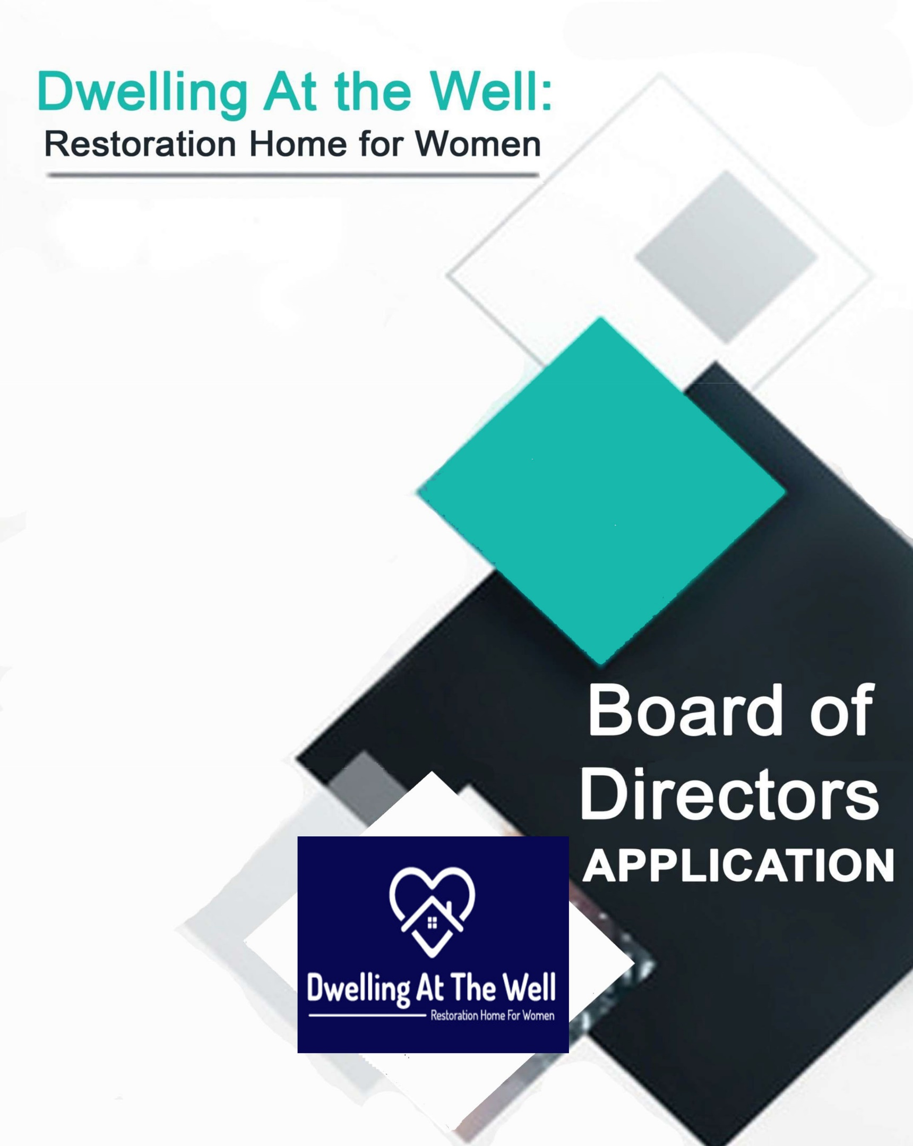

**DWELLING AT THE WELL**

**Board of Directors Application Form**

**Date** ______________________________________________________________

**Name** ______________________________________________________________

**Email** ______________________________________________________________

**Phone** h)__________________w)___________________c)____________________

**Address** ______________________________________________________________

_________________________________________________________________________

**Resume Attached**

**Brief Statement of Interest Attached** - please describe why you would like to join the Dwelling At the Well: Restoration Home for Women Board of Directors and what skills you think you may be able to contribute.

Previous Experience on a board: ___yes ___no

If yes, please specify:_________________________________________________________

**Specific Areas of Relevant Expertise:** *Please select all that apply.*

Accounting or Finance

Addiction and Recovery Specialist: ____________________________________

Artist (Freelance or Corporate)

Communications

Community Relations

Event or Project Management

Fundraising

Grant Writing / Assessment

Human Resources / Personnel Management

Independent Consultant

Law

Marketing

Not-for-profit Experience

Photoshop / Illustrator Expertise

Policy Development

Social Media Engagement / Analytics / Metrics

Strategic Planning

Volunteer Coordination / Management

Other: _______________________________________________

# Board Member Job Description

Orientation and training is provided to make sure directors are comfortable and knowledgeable in their role; previous board experience is an asset but not required.

**Qualifications**

A team player with an interest in women’s recovery and addiction issues with a willingness to:

* Commit time for regular Board meetings, committee meetings and planning sessions
* Attend most events or fundraisers
* Volunteer at special events, if/as needed
* Promote organization and events on social media where applicable
* Prepare for meetings, review and comment on minutes and reports
* Listen well and be thoughtful in considering issues
* Get to know other directors and build a great board that makes a difference
* Actively participate in the board’s annual evaluation and planning efforts
* Understand the fiscal implications of decisions

**Responsibilities**

* Provide strategic leadership
* Be knowledgeable about the organization’s values, mission, programs and performance outcomes
* Be an ambassador for the organization and promote its work in the community
* Ensure the organization’s financial viability and sustainability
* Develop policy frameworks
* Employ and evaluate the performance of the Executive Director
* Participate in fundraising, donate or solicit donations, suggest donors

To carry out these responsibilities, the Board will meet QUARTERLY throughout the year. In addition to attendance at Board meetings, you agree to participate on committees and attend committee meetings as needed/scheduled. The Board will be comprised of no less than 4 and no more than 12 members (including general members) who are elected or invited during the designated election period, typically between October and December. Board Members serve 2 year terms and may serve a maximum of three consecutive 2 year terms (for a total of 6 years). If you or someone you know would like the opportunity to serve as a passionate, knowledgeable, and dedicated officer on our Board of Directors, please complete and submit this Board Application and attach a current Resume and brief Statement of Interest.

=======================================================================

For Committee Use Only

**How did we hear about this applicant:**

Recommended by a current Board member

Recommended by Staff member

Internal Advertisement and Recruitment

External / Public Advertisement and Recruitment

Other __________________________

**Application has been reviewed by the Election Committee**  Date:_________________

**Applicant has been interviewed the Election Committee**  Date:_________________

**Nominee has been interviewed by the Board** Date:_________________

**Action Taken by the Board:** __________________________________________________

________________________________________________ Date:_________________